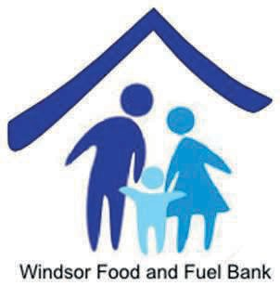

October 1, 2017

Dear Fellow Windsor Residents:

The Windsor Food and Fuel Bank, in cooperation with Windsor Social Services Department and other local organizations, provides support to our community in a variety of ways. We anticipate that the level of need will continue to increase throughout the next year and especially as the winter months approach. With your support, we can continue to provide assistance to our neighbors.

- The Food Bank, located at the L.P.Wilson Community Center, is currently serving over 358 registered households and helping to meet the nutritional needs of more than 814 individuals, including 281 children under the age of 18.

- Our Fuel and Utilities Program continues to assist families with heating and utility expenses in order to assure that they are warm and safe during difficult times.

- Individuals and families facing emergency situations are able to seek assistance through our Basic Needs Program which provides resources for such things as clothing, medication, and transportation.

Please join us as we support our Windsor neighbors in need by making a donation during our annual appeal. By doing so, you will be providing the Windsor Food and Fuel Bank with the resources we must have in order to continue our work.

Your fully tax-deductible donation can be made by visiting our website at www.windsorfoodbank.org or by calling us at (860) 683-4199. Should you have questions or need additional information of any kind, please be certain to contact us. The Windsor Food and Fuel Bank is a non-profit, 501(c)(3) organization led by an all-volunteer board.

Respectfully Yours,
Ernest T. Perreault President

